Writing a Realistic/Fiction Letter
Name:_____________________________ #____ BB O C

Letter writing may be a dying art as communication is growing through emails, Tweets, and Facebook postings, but I love going through my mail and finding a letter in there with my handwritten name on it. Perhaps written by a grateful student, or someone I haven’t seen in a really long time. While not all letters share good news, I find that writing down might thoughts and feelings is extremely more personal than getting an email. That is why we be including it in your portfolios.
Now I understand that many of you have picked a topic that you do not know in real life to write to, so be creative! Create a make believe person, or write to a real person (like the President of the United States) and YOU create yourself as a made up individual. This letter can be realistic fiction. That means it must have the POTENTIAL of happening. Writing a letter to a talking unicorn is NOT realistic fiction…it is just plain fiction!
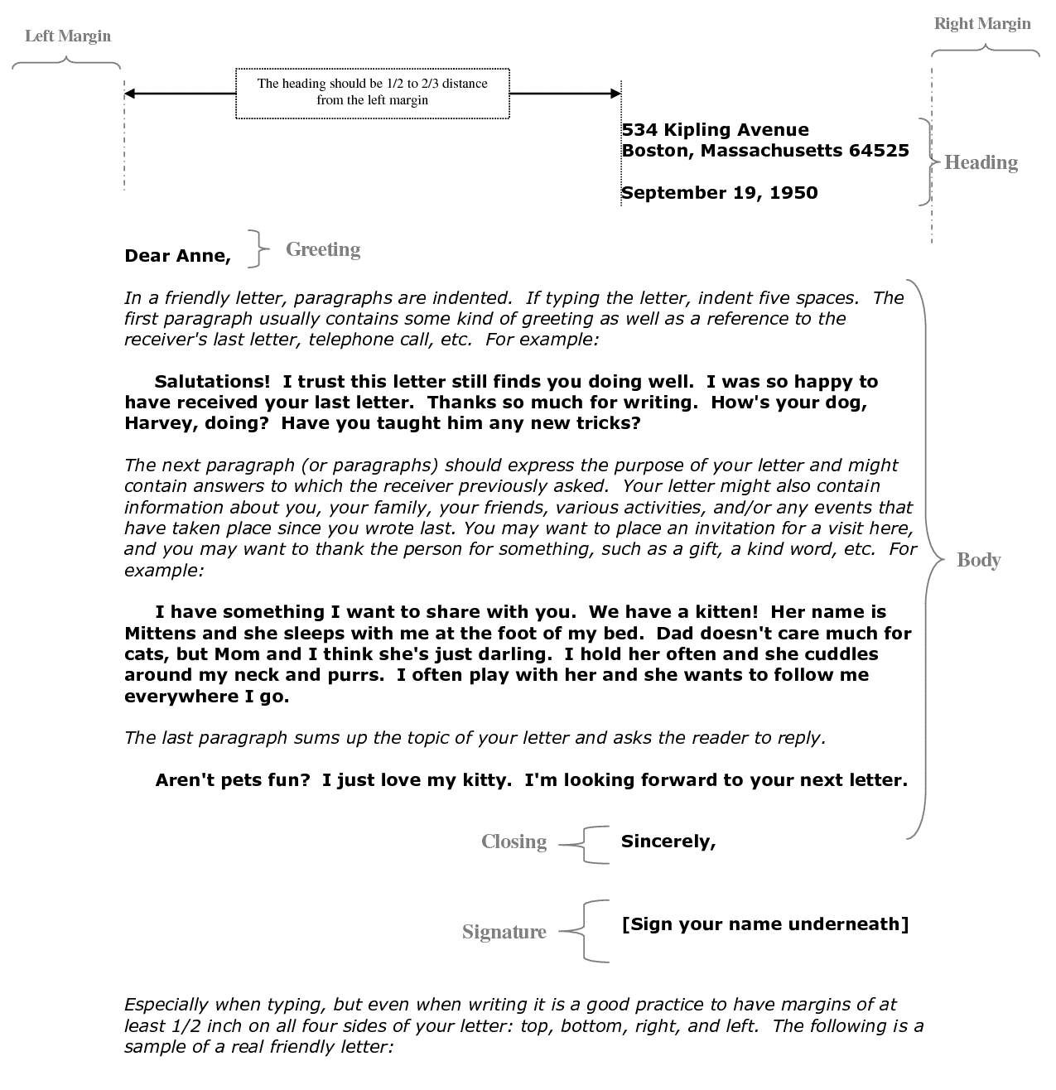
- Your letter needs to include the following
Remember to intend every time you have a new paragraph. You should have at least 3-4 of them!
Enter Twice before leaving a spot to SIGN your name
Tab over about 5-6 times
components that are shown below:

You will also need to include a self-addressed envelope for your letter. Remember your letter may be totally made up and it is OK for you to write a made up sending, and returning address as well.

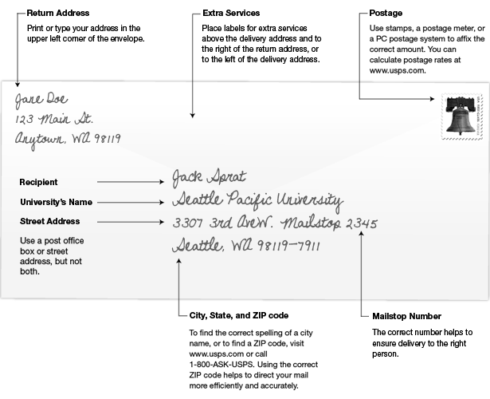
Company Name:

Grading
Was written in Letter format: Includes a
- Heading
- A Greeting
- A Body: 3-4 strong paragraphs that do not repeat, ramble, and connect to portfolio topic.
- A closing
- A signature
- An self-addressed envelope

Letter is 1 full, proper font and proper margin, written/typed page. NOT double spaced. Little grammar/spelling errors are shown. Letter is well thought out and creative. I am able to hear the author’s “voice” and their strong desire writing this letter. All writing documents are present, and the assignment was turned in finished and on time. Growth is shown by making a strong connection to the topic, completion, and hard work.

If you do not want to be left behind then the essay must be finished by: Monday May 9th.

